Basic Tips for Communicating
with People with Aphasia
 | Speak clearly in short, simple sentences
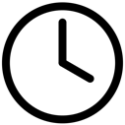 | Be patient, allow plenty of time for a response
 | Remove distractions and reduce background noise
 | Ask Yes or No questions, or give them options to choose from
 | Confirm by repeating back what you think the person said or meant
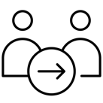 | Talk WITH the person who has aphasia, not FOR them
 | Try writing, gesturing, drawing pictures or using devices

