Example Aphasia Friendly Schedules
*Add as many options for each session as required
Day 1
TIME | ACTIVITY
11:00am – 11:30am | Arrival and Registration | 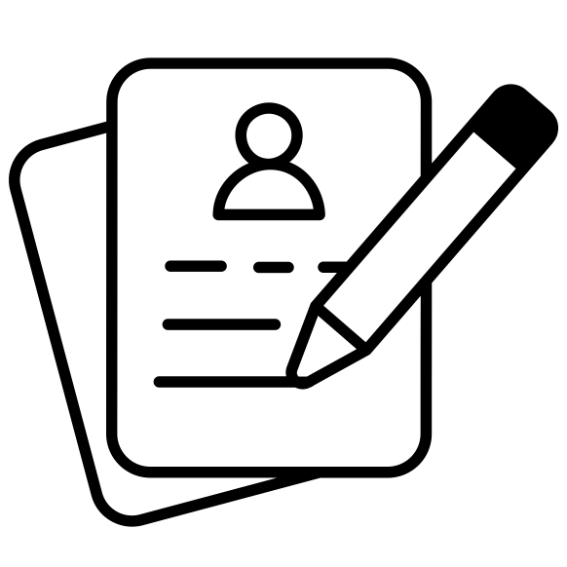
11:30am – 12:30pm | Welcome Session | 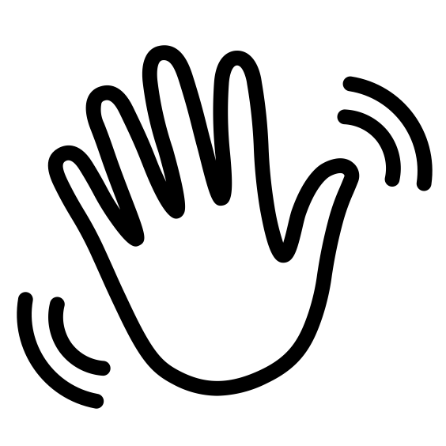
12:30pm – 1:30pm | Lunch | 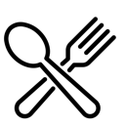
1:30pm – 2:45pm | Activity 1 (e.g. group discussion) | 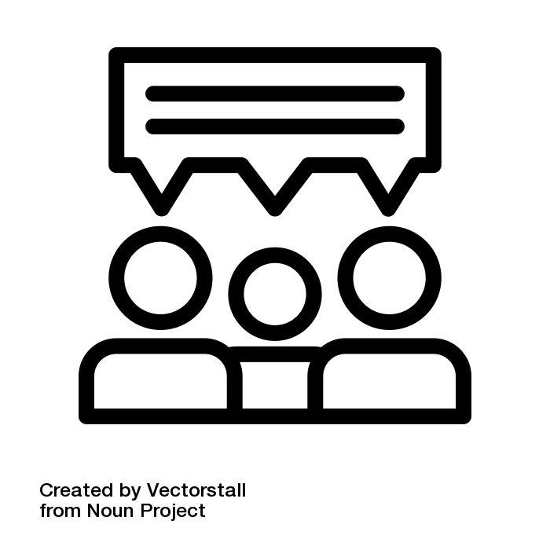
2:45pm – 3:00pm | Afternoon Tea | 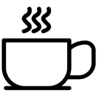
3:00pm – 4:15pm | Activity 2 (e.g. mindfulness) | 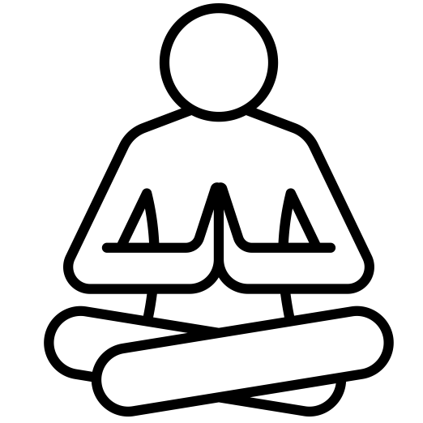
4:15pm – 5:30pm | Activity 3 (e.g. story telling) | 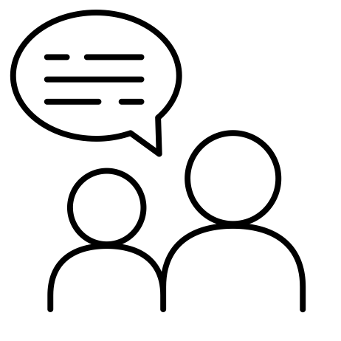
5:30pm – 7:00pm | Dinner
7:00pm onwards | Free Time (or Night Activity) | 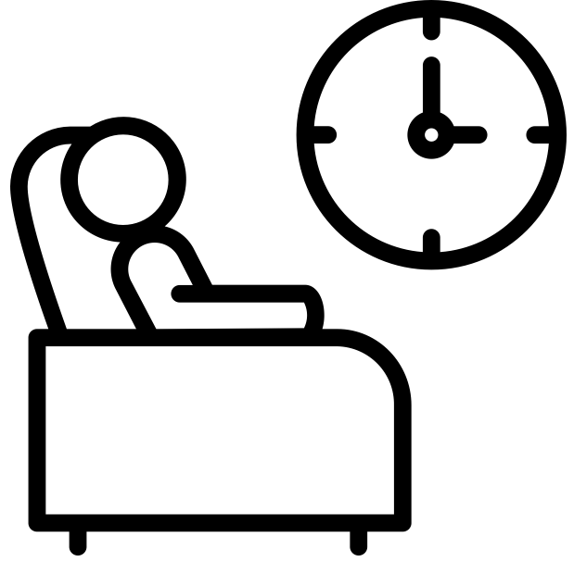
*Icons can be found online (e.g. https://thenounproject.com/)

Day 2
TIME | ACTIVITY
7:00am – 8:00am | Coffee and Tea  (or Morning Activity e.g. walk)
8:00am – 9:00am | Breakfast
9:00am – 10:30am | Activity 1 (e.g. Yoga) | 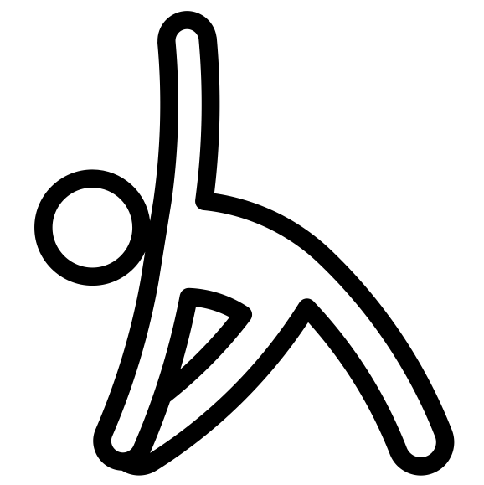
10:30am – 11:00am | Morning Tea
11:00am – 12:30pm | Activity 2 (e.g. Talking Groups)
12:30pm – 1:30pm | Lunch
1:30pm – 2:45pm | Activity 3 (e.g. Arts and Crafts) | 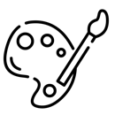
2:45pm – 3:00pm | Afternoon Tea
3:00pm – 4:15pm | Activity 4 (e.g. Lawn Bowls) | 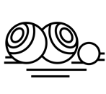
4:15pm – 5:30pm | Activity 5 (e.g. Information Session)  (or Free Time) | 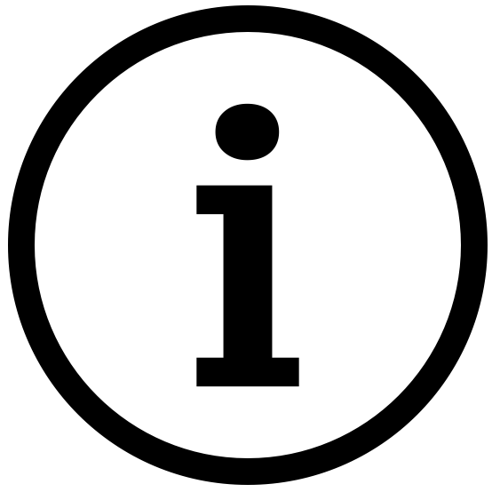
5:30pm – 7:00pm | Dinner
7:00pm onwards | Free Time (or Night Activity)
*Icons can be found online (e.g. https://thenounproject.com/)

Day 3
TIME | ACTIVITY
7:00am – 8:00am | Coffee and Tea  (or Morning Activity e.g. walk)
8:00am – 9:00am | Breakfast
9:00am – 10:30am | Activity 1 (e.g. technology and apps) | 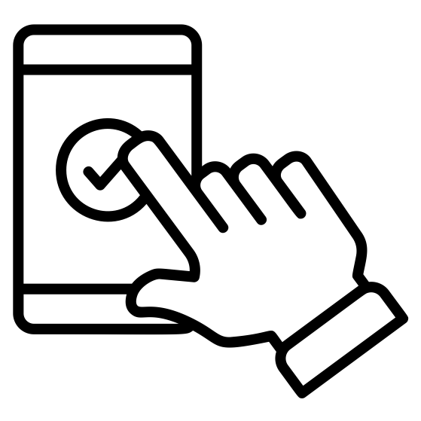
10:30am – 11:00am | Morning Tea
11:00am – 12:30pm | Activity 2 (e.g. singing group) | 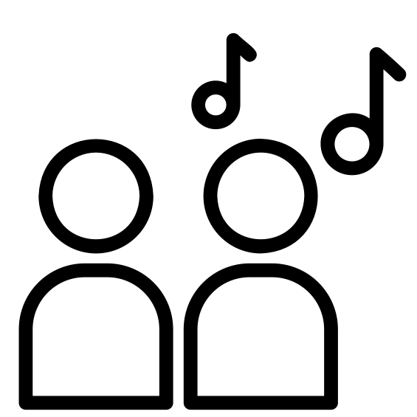
12:30pm – 1:30pm | Lunch
1:30pm – 2:45pm | Activity 3 (e.g. games) | 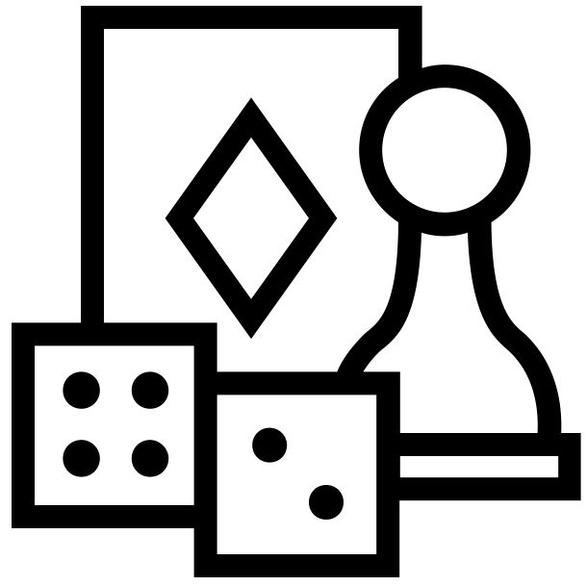
2:45pm – 3:00pm | Afternoon Tea
3:00pm – 5:00pm | Wrap Up Session
*Icons can be found online (e.g. https://thenounproject.com/)

