Example Feedback Form
*Add/remove any sections as needed

We want to know your thoughts on the aphasia camp!

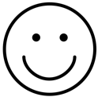 What went well?

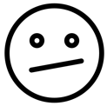 What didn’t go well?

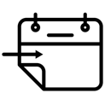 What do you want to see next time?

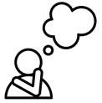 Tell us your favourite memory from camp!

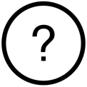 Any other comments?

If you have any other comments, questions or feedback,
please contact us at XXXXXX@email.com or (XX) XXXX XXXX
*Icons can be found online (e.g. https://thenounproject.com/)

