Example Registration Form
*Add/remove any sections as needed

Personal Details

First Name | Last Name
Address | City and Postcode
Email Address | Phone Number
Date of Birth (day/month/year)  / / | Gender  ☐ Male ☐ Female  ☐ Other: ________________
Emergency Contact Name | Emergency Contact Number

☐ I am a person with aphasia and I am accompanied by ______________ (name)
who is my spouse/child/parent/friend/carer/other:______________
☐ I am a person with aphasia and I am attending alone
☐ I am a friend/family member/carer accompanying ______________ (name)
Have you attended a camp before?
☐ Yes – what year/s? __________________ ☐ No

Health Information

What caused your aphasia?  When did it happen? |  | Do you have Primary Progressive Aphasia?  ☐ Yes – year diagnosed: ____________  ☐ No
Do you have allergies?  ☐ Yes – allergic to: __________________________ ___________________________________  ☐ No |  | If you have allergies, do you use an EpiPen?  ☐ Yes  ☐ No
Do you have any health conditions? check all that apply
☐ Seizures  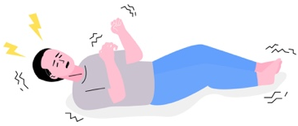 | ☐ Headache/migraines  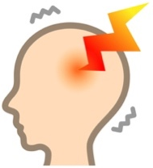 | ☐ Brain Injury  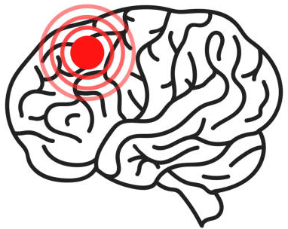 | ☐ Blood pressure    ☐ Low ☐ High
☐ Heart attack  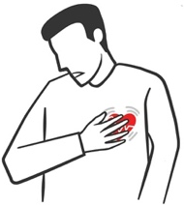 | ☐ Other heart condition   | ☐ Chronic pain/arthritis  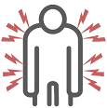 | ☐Diabetes  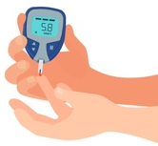  ☐ Type 1 ☐ Type 2
☐ Asthma  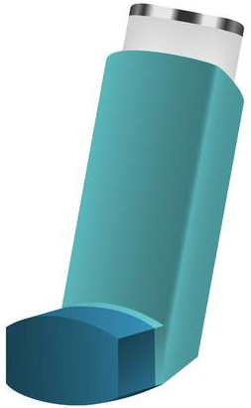 | ☐ Breathing problems  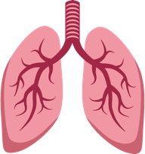 | ☐ Hearing loss    ☐ Hearing aids | ☐ Vision loss    ☐ Glasses
☐ Other

Do you need help when taking medications while on camp?
☐ Yes ☐ No
If yes, please provide information about your medications and assistance needed:

Dietary Requirements

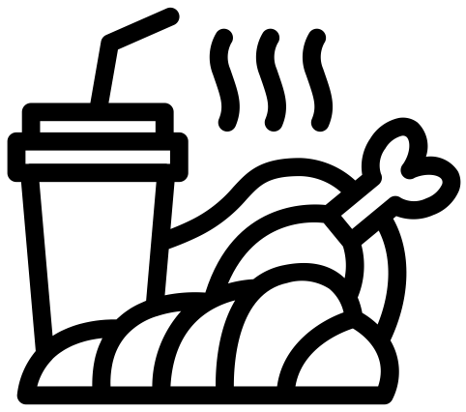 Do you have special dietary requirements
☐ Yes ☐ No
If yes, check all that apply:
☐ Diabetic ☐ Vegetarian ☐ Vegan
☐ Gluten free ☐ Dairy free ☐ Nut free
☐ Low salt ☐ Halal ☐ Kosher
☐ Other _________________________________________________________________________
Do you have a modified diet?
☐ Yes ☐ No
Food: ☐ Pureed ☐ Minced and moist ☐ Soft and bite-sized
Fluid: ☐ Mildly thick ☐ Moderately thick ☐ Extremely thick
Other:

Mobility

Do you use an assistive device to move around?
☐ Yes ☐ No
If yes, what kind of device?
☐ Cane  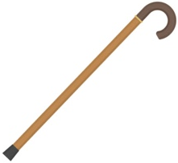 | ☐ Walking frame  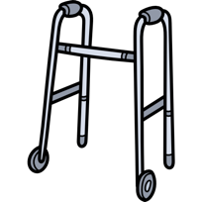 | ☐ Wheelchair  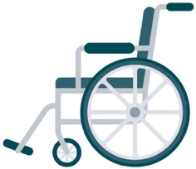 | ☐ Other:
Do you require assistance to move around?
☐ Yes ☐ No
Can you climb stairs independently?
☐ Yes ☐ Yes, but only _____ steps ☐ No
Do you require assistance with any other activities?
☐ Yes ☐ No
If yes, what kind of activities?
☐ Eating/Drinking | ☐ Toileting   | ☐ Sitting/Standing  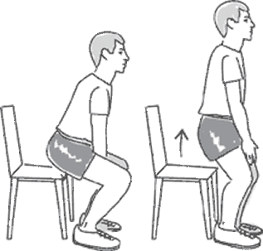 | ☐ Other:

Communication

Do you have difficulty with…?
☐ Talking   | ☐ Understanding   | ☐ Reading   | ☐ Writing  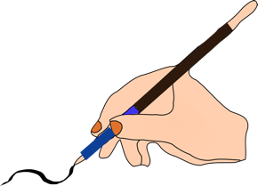
☐ Other:

What helps you communicate?
☐ Key Words   | ☐ Writing/drawing | ☐ Communication book  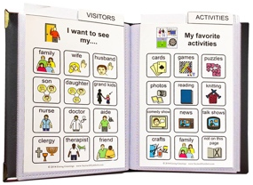 | 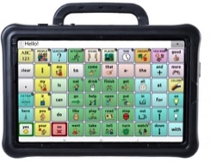  ☐ Communication device
☐ iPad/technology  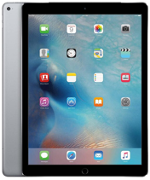 | ☐ Using pictures  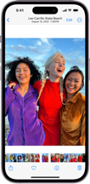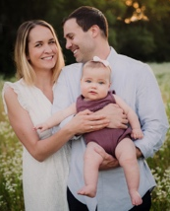 | ☐ Pointing/gesturing   |   ☐Help from family/ friends
☐ Having extra time  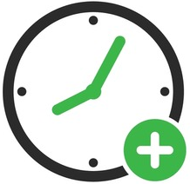 | ☐ Having choices  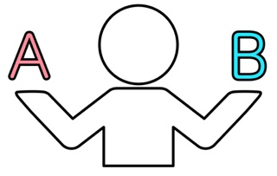 |   ☐ People speaking slowly |   ☐ Removing noise/ distractions
☐ Other:

About You

What are your interests and hobbies?

What is/was your profession/s?

Who are your family/important relationships?

What are you looking forward to at the camp?
☐ Meeting new people who are also living  with aphasia | ☐ Find support for living with aphasia
☐ Participate in activities | ☐ Learn more about aphasia
☐ Practice communication | ☐ Spend time with others
☐ Other:

Any other comments?

